**XTrans Annotation**

* **Install XTrans Software**

[XTrans Downloads | Linguistic Data Consortium (upenn.edu)](https://www.ldc.upenn.edu/language-resources/tools/xtrans/xtrans-downloads)

* **Follow the given below steps:**

**Step 1:**  Open XTrans Software

**Step 2:**  Click the option “File” on the top left corner and then select “Open audio file” from the drop-down menu.

**Step 3:**  Select your intended audio file from the folder where it is saved. Click “Open”. The audio file will appear on XTrans. Two boxes on the right side must be selected to listen to the audio in both headphones.

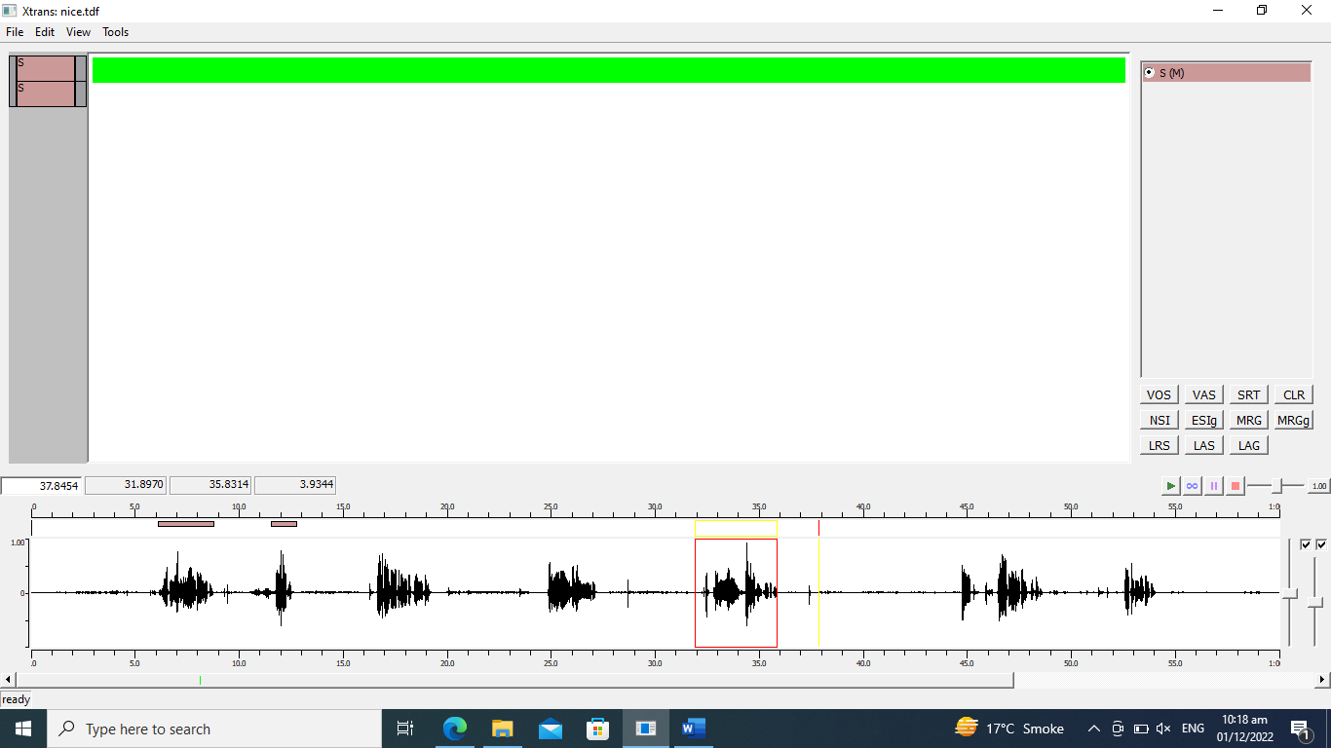

**Step 4:**  Now select a valid chunk of speaker’s audio by pressing left button from the start of the statement to the end of the sentence. The selected chunk will be enclosed in red-lined boundary box.



**Step 5:**  Now Press “Ctrl+N”. A dialogue box will be appeared.

**Step 6:**  Rename “Speaker ID”. Select “Speaker Type” as Male or Female. And then press “OK”. A new green highlighted segment will be appeared on the screen.

**Note:** A segment’s duration shouldn’t exceed 15 seconds.

**Step 7:**  Similarly, repeat the same step for adding segments by pressing “Ctrl+N”.

**Step 8:**  Now press the option “View” on the top left corner and select “Align right” from the drop-down menu. Text will appear on the right side of the screen.

**Step 9:**  For saving your file, Click the option “File” on the top left corner and then select “Save as” from the drop-down menu. Give a valid title preferably the audio file name to your file. Select the location of the folder where you want to save your file and then press “Save”. The file will be saved in the folder.

**Additional Information:** If you want to Rename your speaker’s name or ID, click right on the speaker’s name or id. Select the option “Edit speaker information(global)”. A dialogue box will appear. You can rename your Speaker ID. Then press “OK”. All the segments will be renamed.

Audio Preprocessing for Speaker Identification

1. Generate utterances of duration 3 to 15 seconds from an audio.

Now each audio is subdivided into smaller audio segments.

1. Gather 3 to 15 seconds of audio segments for the train datatest.
   1. Collect 5 minutes of audios (total duration of audio segments) for the training dataset.
2. Gather 3 to 10 seconds of audio segments for the test datatest.
   1. Collect 3 minutes of audios (total duration of audio segments) for the testing dataset

At the end you should have

1. 5 minutes of audio segments for each speaker in the train dataset.
2. 3 minutes of audio segments for each speaker in the test dataset.